SARDAR VALLABHBHAI NATIONAL INSTITUTE OF TECHNOLOGY, SURAT
DEPARTMENT OF CIVIL ENGINEERING
STRUCTURAL ENGINEERING SECTION
EXPERIMENTAL STRESS ANALYSIS LABORATORY
Experimental Stress Analysis Laboratory was established in 1974. The laboratory is located behind the Department of Civil Engineering Wing B. Postgraduate students utilize laboratory facilities for their curriculum laboratory work. Ph.D. Research scholars also utilize it for their research purposes. It is one of the key laboratory for PG students. The laboratory has good potential to carry out research in structural engineering. This laboratory is designed to understand the stress-strain behaviour of the various structural elements with applying appropriate strain gauge techniques. The list of equipment available in the laboratory is given below:
Sr. No. | Equipment Name
1 | Universal Testing Machine
2 | Compression Testing Machine
3 | Extensometers
4 | Compresso-meter
5 | Polariscope
6 | Concrete Core Drills
7 | Strain Gauge
Information Regarding Few Important Set-ups in the Concrete Technology Laboratory
Universal Testing Machine:
A Universal testing machine (UTM) tests the mechanical properties (tension, compression, etc.) of the specimen by using tensile, compressive, or transverse stresses. The machine has been named so because of its wide range of tests over different materials. Different tests, like peel, flexural, tension, bend, friction, spring, etc., can be performed with the help of UTM. UTM is depicted in Figure 1 and 2.
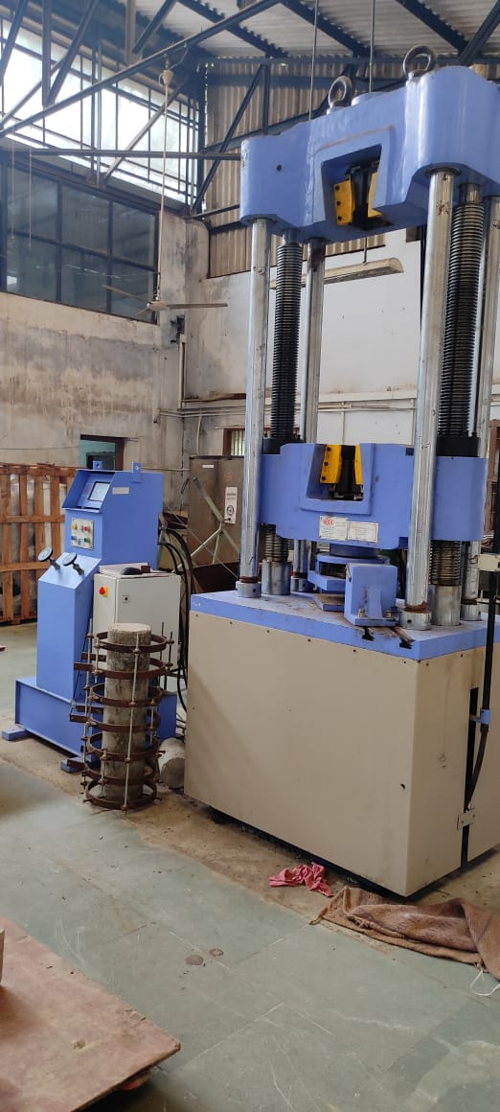
Figure.1 Digital Universal Testing Machine
Figure 2. Analog Universal Testing Machine

Compression Testing Machine
A compression testing machine is a universal testing machine (UTM) specially configured to determine a material's strength and deformation behavior under compressive (pressing) load. A typical compression tester consists of a load cell, crosshead(s), compression test tools, electronics, and a drive system. It is shown in figure 3.
Figure 3. Compression Testing Machine
Extensometer
An extensometer is a device that is used to measure changes in the length of an object. It is useful for stress-strain measurements and tensile tests. Its name comes from "extension-meter". It was invented by Charles Huston who described it in an article in the Journal of the Franklin Institute in 1879. Huston later gave the rights to Fairbanks & Ewing, a major manufacturer of testing machines and scales.
Compressometer
A compressometer is a device used to determine the strain or deformation of a specimen while measuring the compressive strength of concrete specimens, generally a cylinder. It can be used for rock, concrete, soils, and other materials. For concrete, the device usually comprises two steel rings for clamping to the specimen and two-gauge length bars attached to the ring. When the compressive load is applied, the strain value is registered from the compressometer. Generally, a data logger is used to record the strain. Figure 4. shows compressometer.
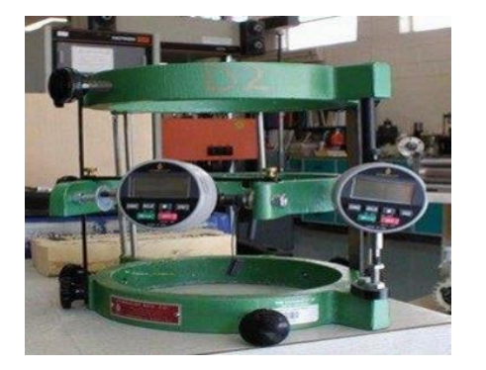
Figure 4. Compressometer

Polariscope
The polariscope is an optical inspection device used to detect internal stresses in glass and other transparent materials such as plastics, synthetic resins, etc. A polariscope is composed chiefly of a light source and two crossed polarized lenses such as Polaroid. The polariscope light source is mounted beneath one lens, and is powered by either self-contained batteries or an external power source. Material to be examined is placed between the two polariscope lenses and viewed through the lens opposite the light source lens. Polariscopes are manufactured in configurations that very from standard portable units, ordinarily carried in stock, to instruments custom made for specific applications. Figure 5. shows polariscope.
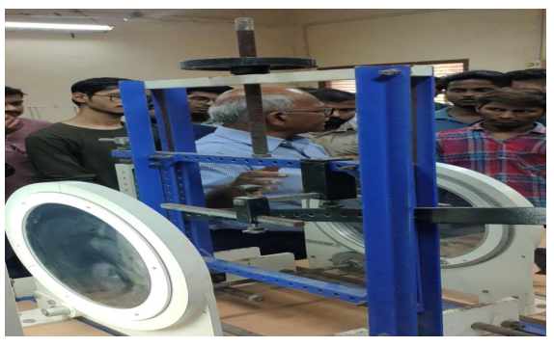
Figure 5. Polariscope
Concrete Core Drills
A modern core drill is a drill specifically designed to remove a cylinder of material, much like a hole saw. The material left inside the drill bit is referred to as the core. Core drills used in metal are called annular cutters. Core drills used for concrete and hard rock generally use industrial diamond grit as the abrasive material and may be electrical, pneumatic or hydraulic powered. Core drills are commonly water cooled, and the water also carries away the fine waste as a slurry. For drilling masonry, carbide core drills can be used, but diamond is more successful when cutting through rebar.
The earliest core drills were those used by the ancient Egyptians, invented in 3000 BC. Core drills are used for many applications, either where the core needs to be preserved (the drilling apparatus used in obtaining a core sample is often referred to as a corer), or where drilling can be done more rapidly since much less material needs to be removed than with a standard bit. This is the reason that diamond-tipped core drills are commonly used in construction to create holes for pipes, manholes, and other large-diameter penetrations in concrete or stone. Core drills are used frequently in mineral exploration where the coring may be several hundred to several thousand feet in length. The core samples are recovered and examined by geologists for mineral percentages and stratigraphic contact points. This gives exploration companies the information necessary to begin or abandon mining operations in a particular area.
Strain gauges
A strain gauge (also spelled strain gage) is a device used to measure strain on an object. Invented by Edward E. Simmons and Arthur C. Ruge in 1938, the most common type of strain gauge consists of an insulating flexible backing which supports a metallic foil pattern. The gauge is attached to the object by a suitable adhesive, such as cyanoacrylate. As the object is deformed, the foil is deformed, causing its electrical resistance to change. This resistance change, usually measured using a Wheatstone bridge, is related to the strain by the quantity known as the gauge factor.

LIST OF EXPERIMENTS
Concrete Technology (M. Tech-I (Structure), Semester- I)
Sr. No. | Title of Experiment
1 | To determine the stress-strain behaviour of mild steel using mechanical gauge (Huggenburger) and electrical stain gauge.
2 | To determine the modulus of elasticity and modulus of rupture of wooden beam, concrete using mechanical gauges.
3 | Demonstration of fringe order using the polariscope.
4 | Demonstration and applicability of brittle coating method.
5 | Report preparation of condition assessment through visual inspection of site visit and suggest the appropriate techniques for repair/retrofit of the structures.
6 | Determine the residual compressive strength of concrete structure using non-destructive test (Rebound Hammer and UPV) and core test.
7 | Demonstration of graphical representation for different theories of failure for 2-D stress system.

